**LAB ASSIGNMENT – 8**

Grihit Budhiraja

19BCE2141

**Bus Topology**

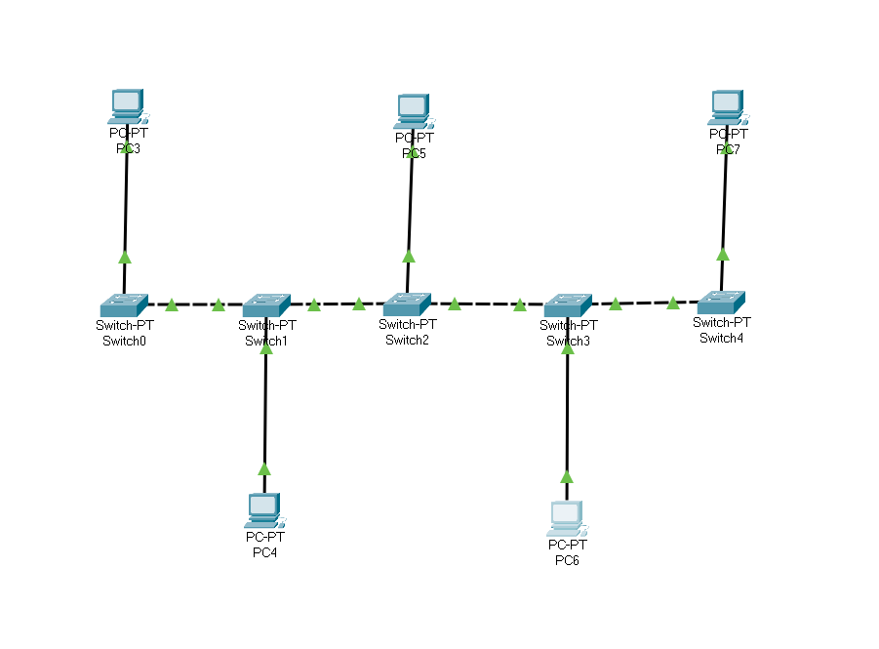

**Ring Topology**

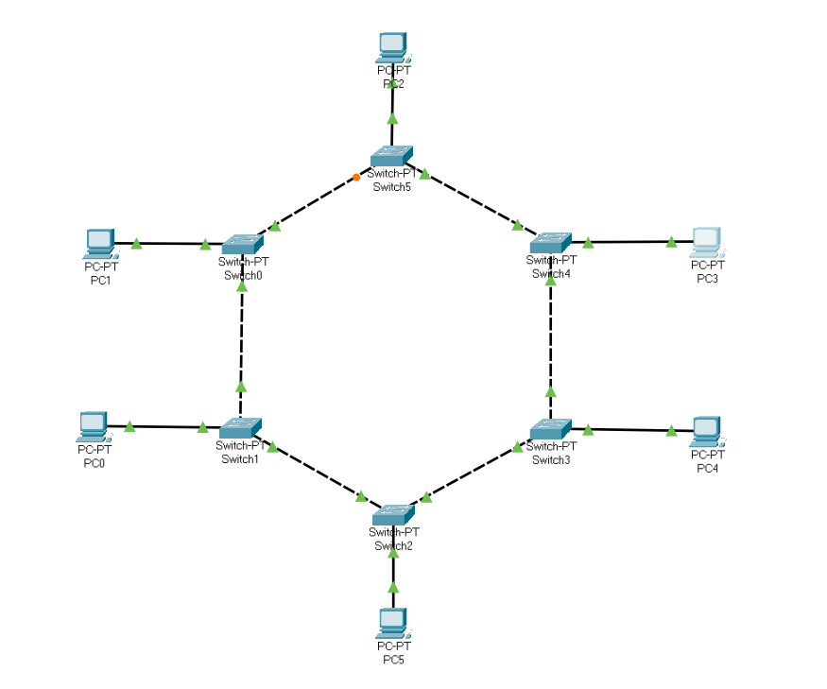

**Full Mesh Topology**

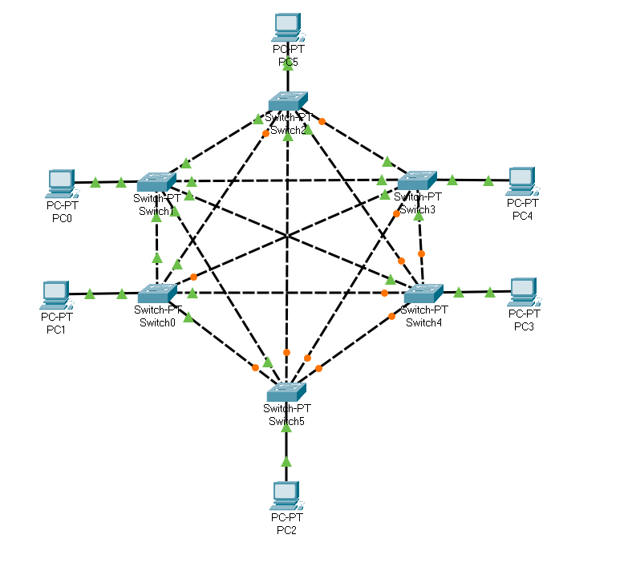

**Star Topology**

